**Program-1**

def largestnum(l):

for k in range(0, len(l)):

for j in range(k + 1, len(l)):

s1 = l[k] + l[j]

s2 = l[j] + l[k]

if (s2 > s1):

tem = l[k]

l[k] = l[j]

l[j] = tem

print("Largest number formed is :", end="")

for k in l:

print(k, end="")

l = []

print("Enter the numbers :", end="")

l = input().split()

largestnum(l)

**(Output)**

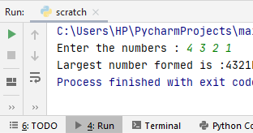

**Program-2**

a=[]

n=int(input("enter the number of elements in the list: "))

a=[int(x) for x in input("Enter values").split(' ')]

print("The original list:{}".format(a))

number="".join([str(i) for i in a ])

length=len(number)

print("The number of digits present in the list are :{}".format(length))

print("The updated list after adding trailing zeros:",end=" ")

print([int(str(num).ljust(length, '0')) for num in a])

**(Output)**

